**Data Storytelling Project: CORONA VIRUS(Covid19)**

**Introduction**

Corona virus diseases (covid-19) are a family of communicable disease that can cause respiratory illness (such as severe acute respiratory syndrome (SARS), Middle East Respiratory syndrome (MERS) in humans.

SARS-CoV-2 was the first strain of corona virus to be reported in Wuhan, china in December 2019. Since then there has been cases in different part of the world. On January 30th WHO declared Covid-19 a global health emergency. On March 11th WHO declared Covid-19 a global pandemic.

Corona viruses are found in animals such as bats, cats and camels. They in but don’t affect the animals. The virus can mutate as they transfer to other species. It was able to transfer from animal species and infect humans. The first case of SARS-CoV-2 was suspected to have been contracted at a market place that sold meat, fish and live animals.

The virus spread from person to person through infected air droplet projected during sneezing or coughing. It can also be contracted by coming in contact with an infected surface and using the contaminated hands to touch your nose, mouth or eyes.

**Aims and Objectives**

The aim of this project is to look at the current situation of covid19 months after the lockdown.

With this analysis we could try to predict future pattern of the virus and find the best method to end the virus for good.

**Flow Process**

**Data Sourcing:** this project was scraped using python library (beautiful soup) from <https://www.worldometers.info/coronavirus/#main_table>.

**Data Preparation:** This has to do with wrangling, cleaning, and removal of outliers. It also includes exploratory data analysis in order to derive meaningful insights from the dataset.

The analysis was made using jupyter notebook and python libraries to scrape, save in csv and create visual to reveal patterns and trends.

**Findings:**  
in most country the number of death is lesser than the number recovered. We have less critical cases and more people are recovering from covid 19.

**RESULTS:**

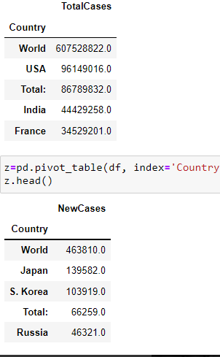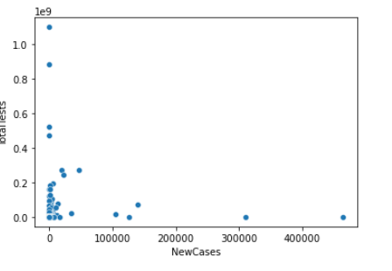

**Conclusion:**

We are on the right track of finally defeating covid 19 for good.

Thank you for reading